Complete these steps before the class on Tuesday, February 10.

1) Create a Gmail account [Skip this step if you created one for last assignment using n8n]
- Add a credit card in Google Cloud Console.
- This unlocks the free $300 credit.
2) Create social media accounts: Make sure all accounts have public access.
- Set up accounts on YouTube (account and Channel), Instagram, Facebook (Account & Facebook Page), and X.
- Use the same Gmail account for all platforms.
Requirements
- Instagram must be a Professional account with public access.
- Link Instagram to your Facebook account.
Facebook Page creation:
Go to your Profile- and select the below option, under that select the page:
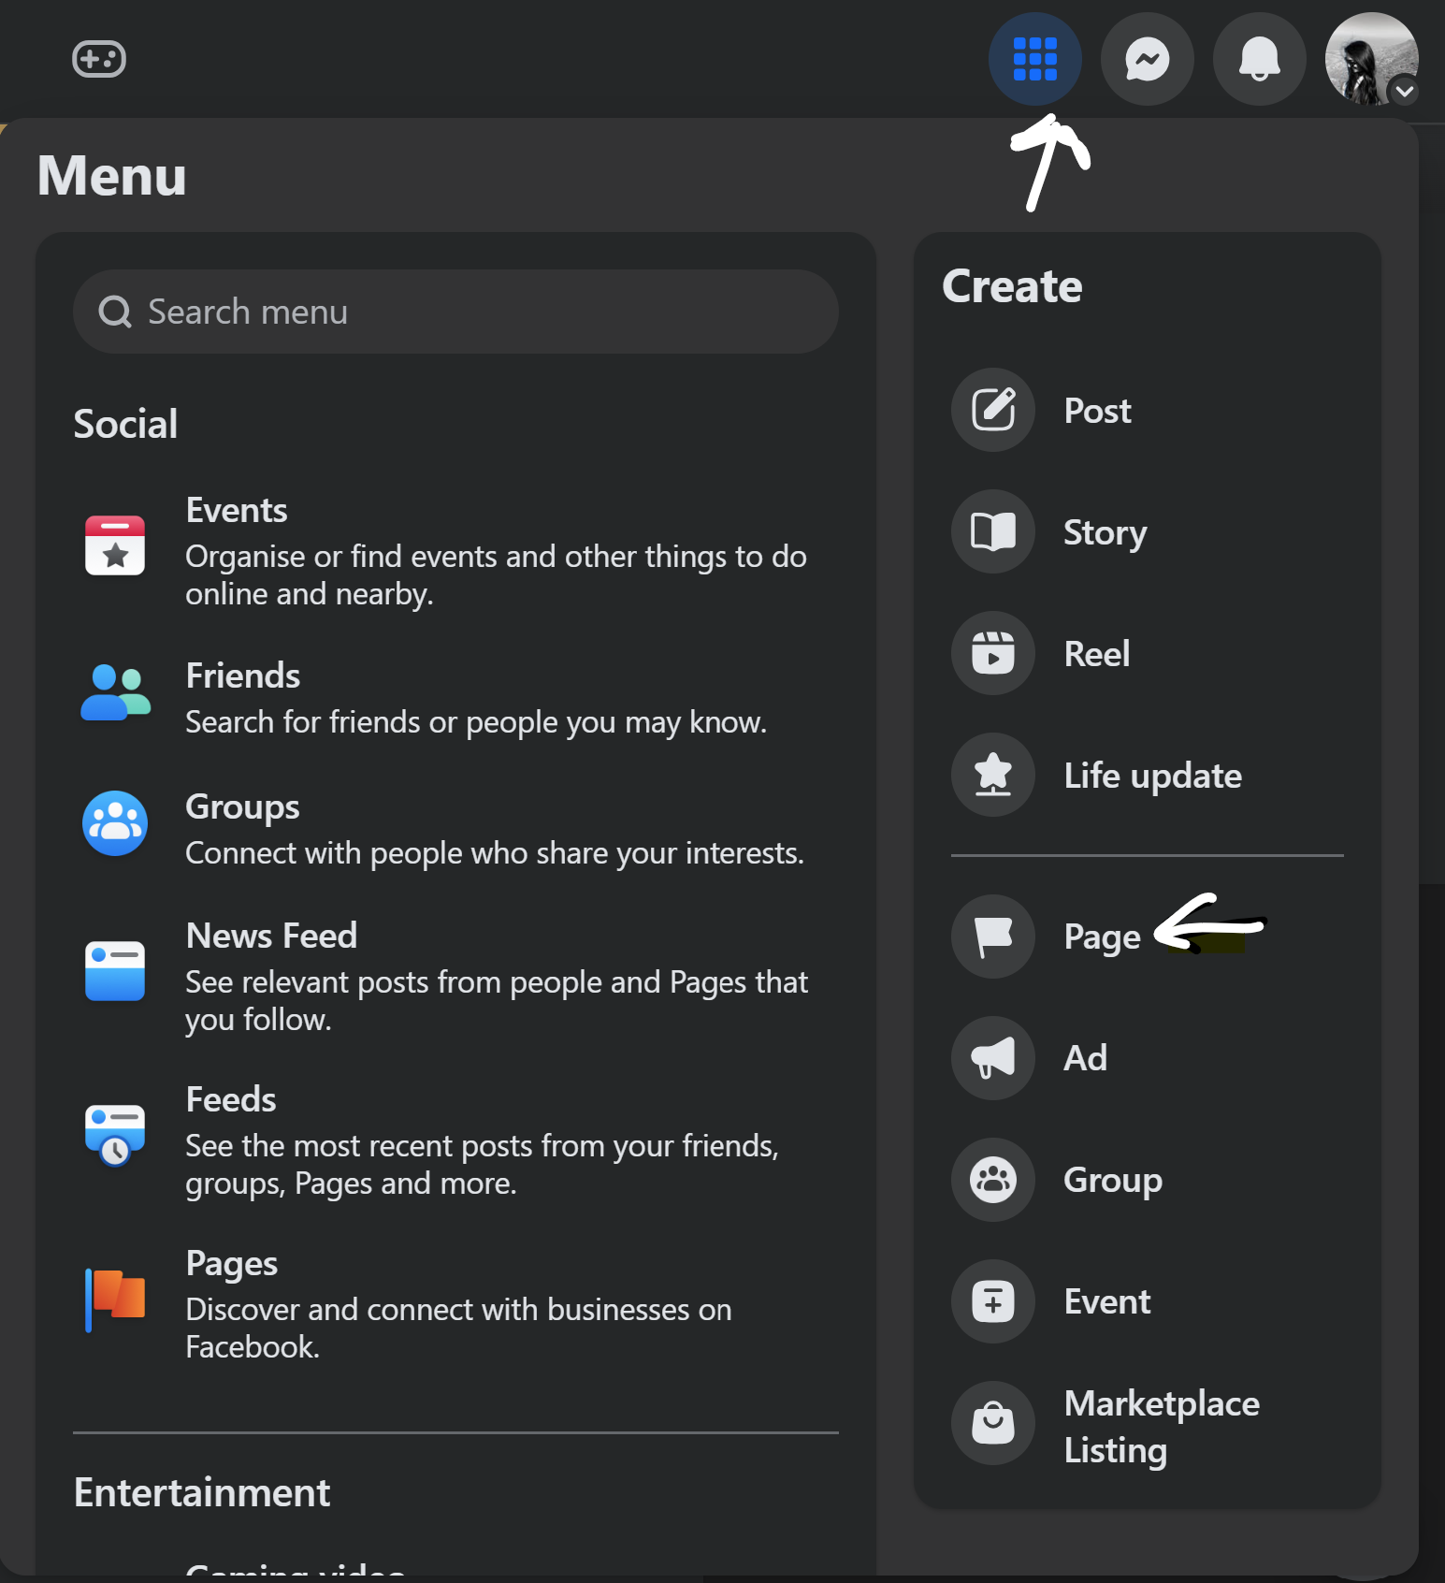

Once selected: Create the Page: Page name: As you wish, Category: Business/Education.

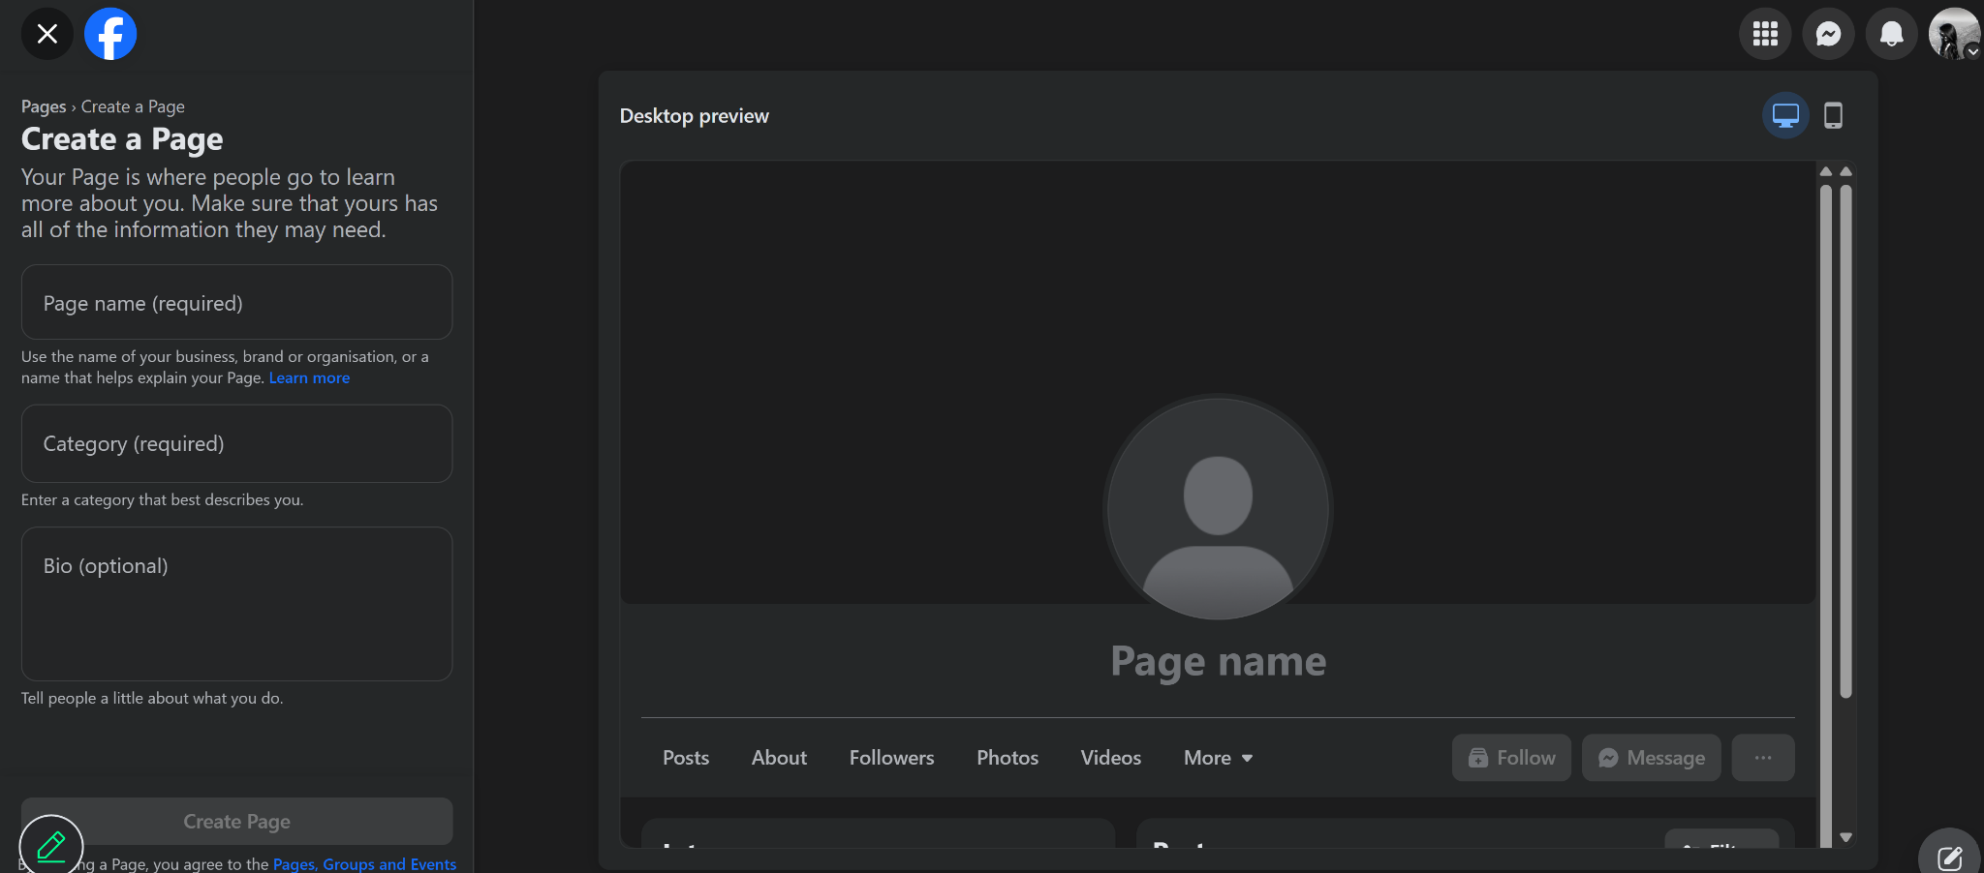

YouTube Channel Creation:
If the Channel is already created: Follow the steps below: Go to your account icon, select View your channel
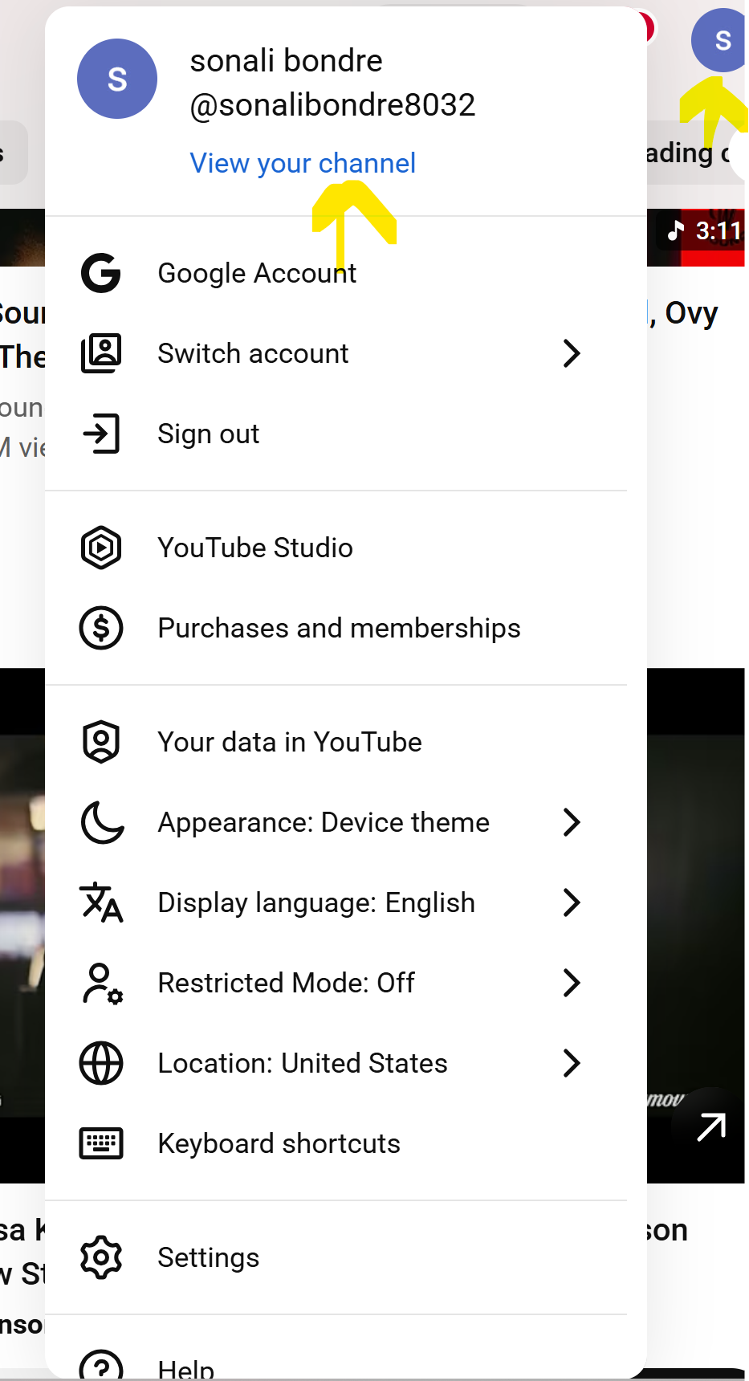

And then select manage videos, you will see the screen like this: You will see the uploaded videos in this screen:

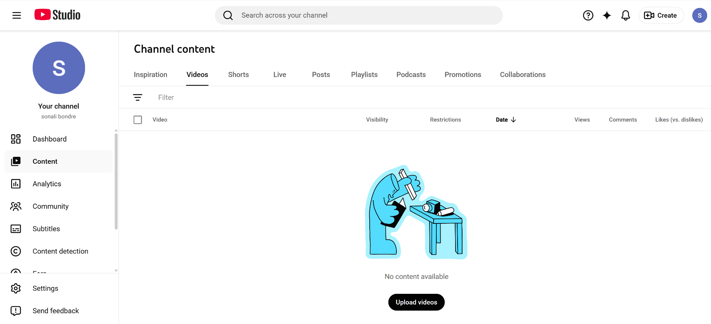

If you are creating a new YouTube channel, Follow the below steps:

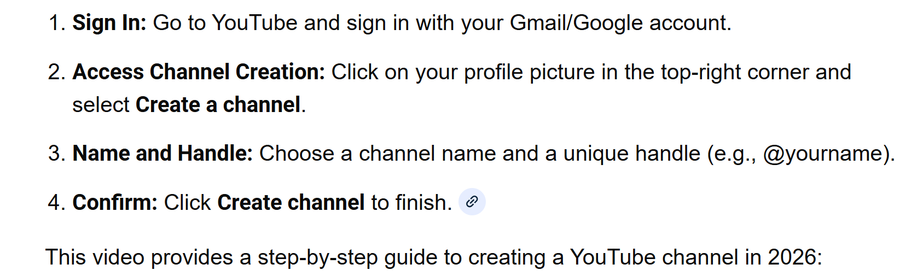
3) Set up Google OAuth (For every new/existing Google Account; Skip this step if you already did this for last n8n assignment)
- This was completed during the first n8n exercise.
(This step should be completed for the Gmail account that will be used for N8N setup.).
If you have not done so, follow the instructions in the PDF saved on Blackboard titled “Documentation for API Keys and OAuth.”
4) Create an Upload Post account
- Sign in using the same Gmail account linked to your social media accounts.
Setup steps
- Go to https://www.upload-post.com/
- Create a free account. Select Sign in with Google.
- Open Users and add a new profile.
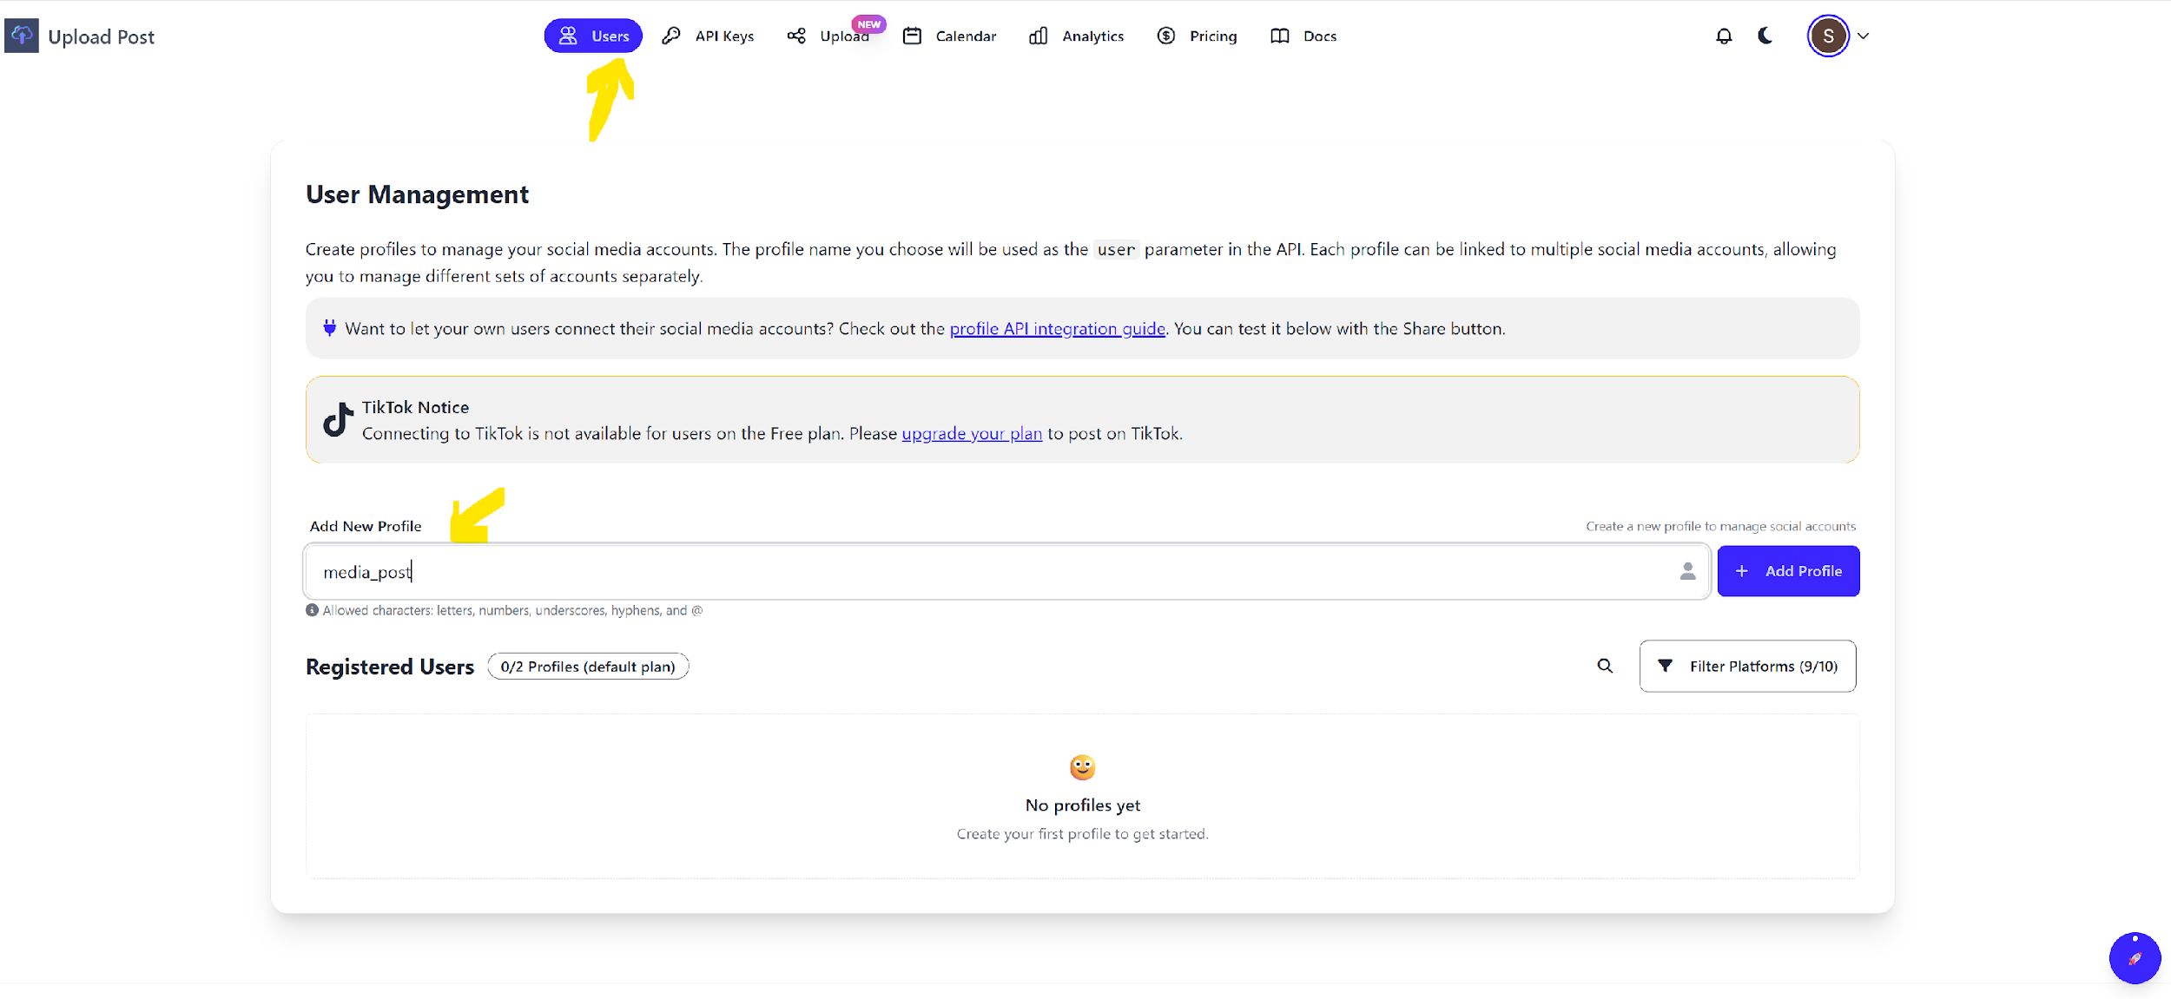
  - After creating the profile, scroll to Social Accounts.
  - Connect X, Instagram, YouTube, and Facebook.
  - You will be redirected to each platform’s login page. Sign in and grant all permissions to “Upload Post”.
  - Confirm that each social media account appears under your profile.
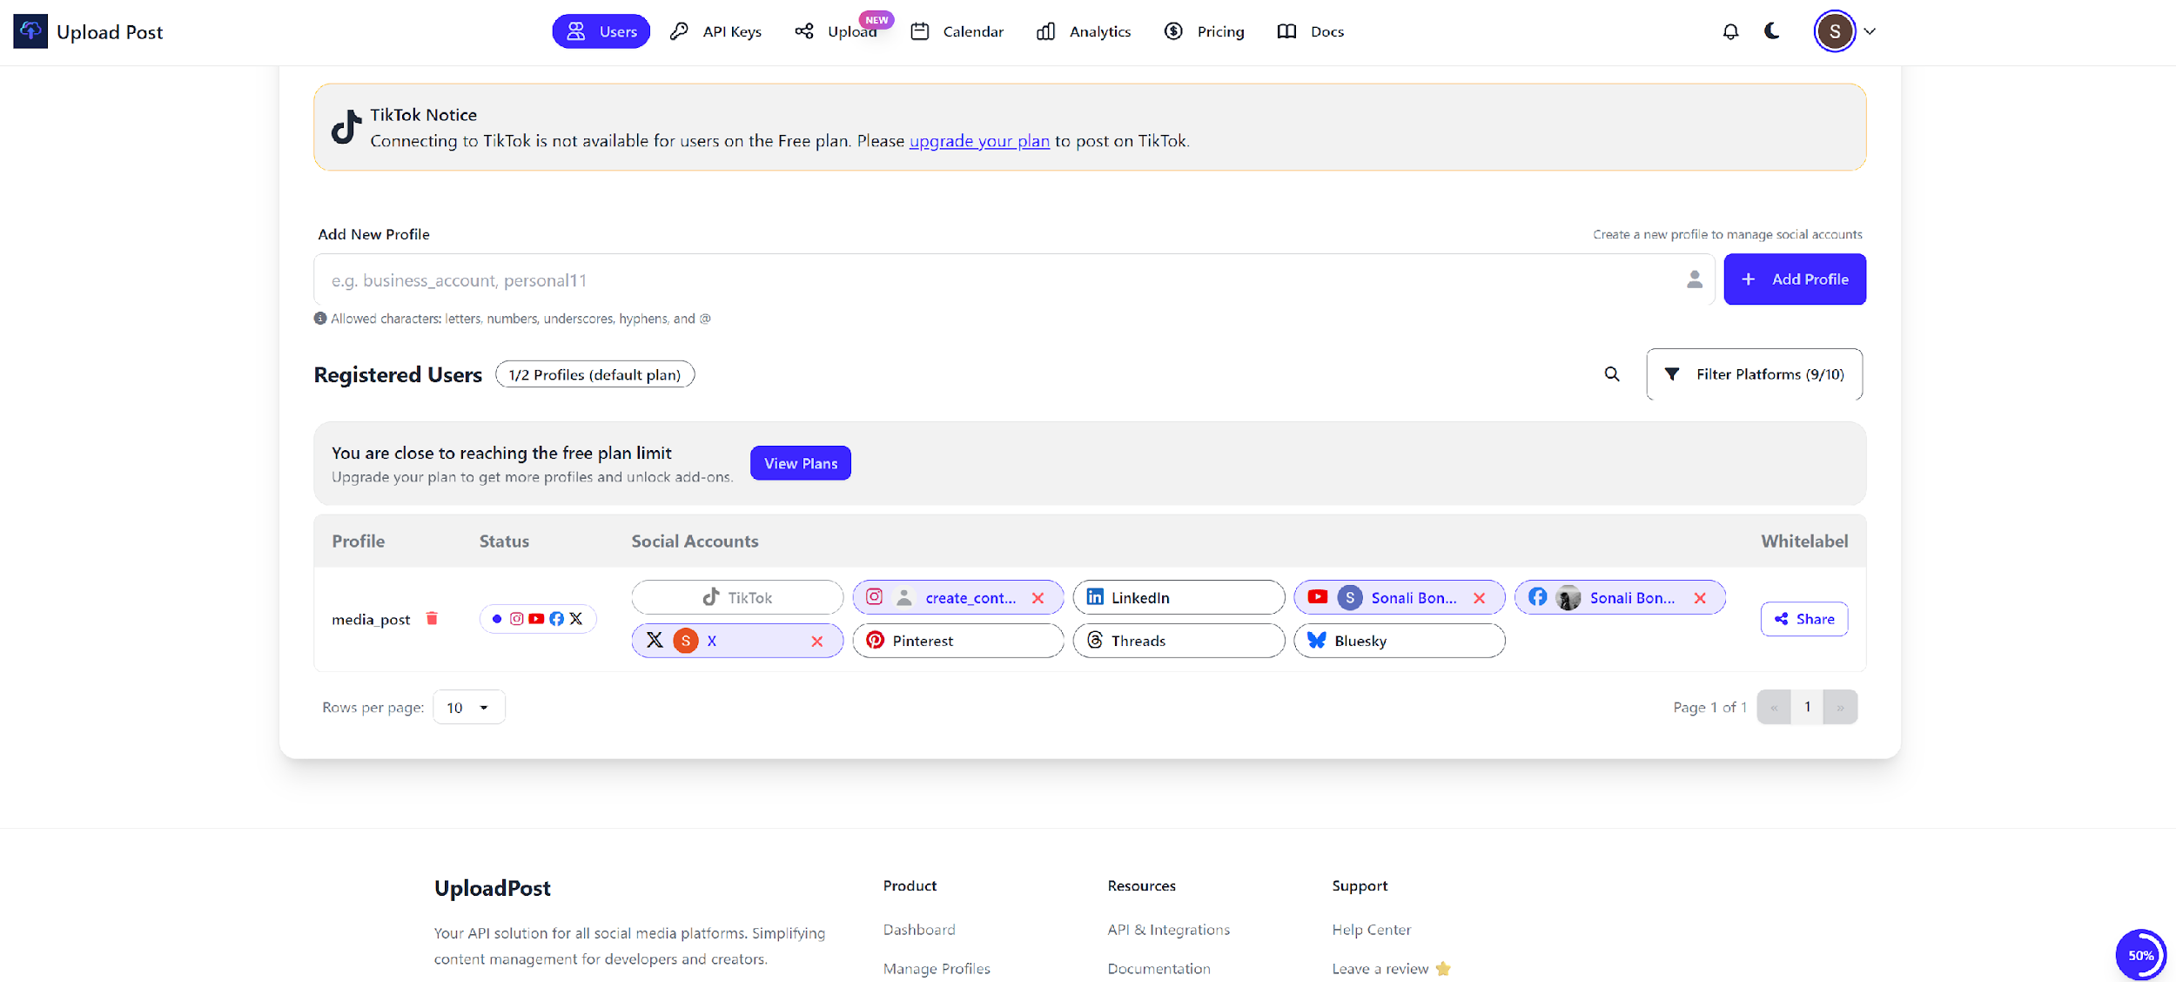
Note: The free plan allows up to 10 posts per month.

8. Create an API key under upload post: This API key will be used in n8n.
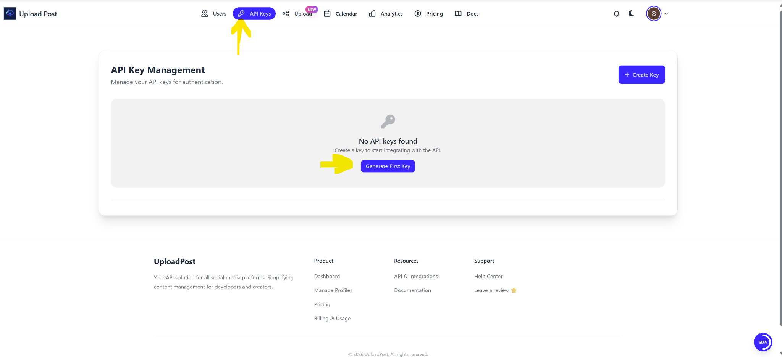

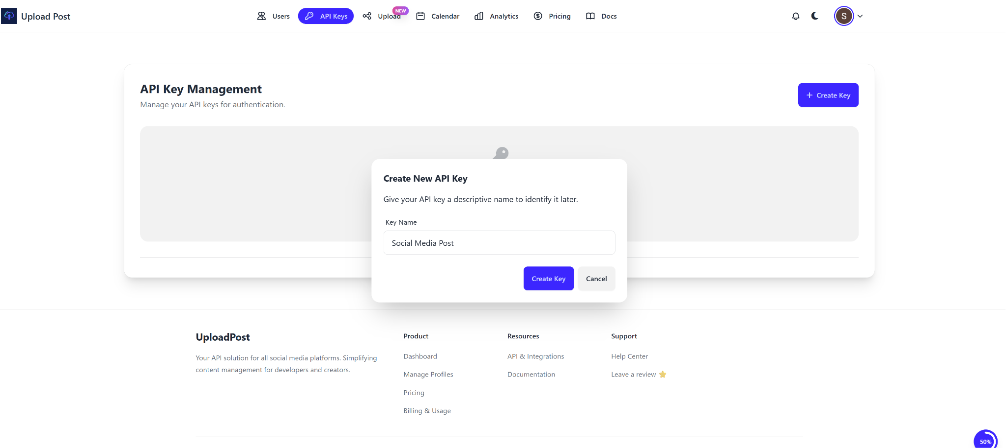

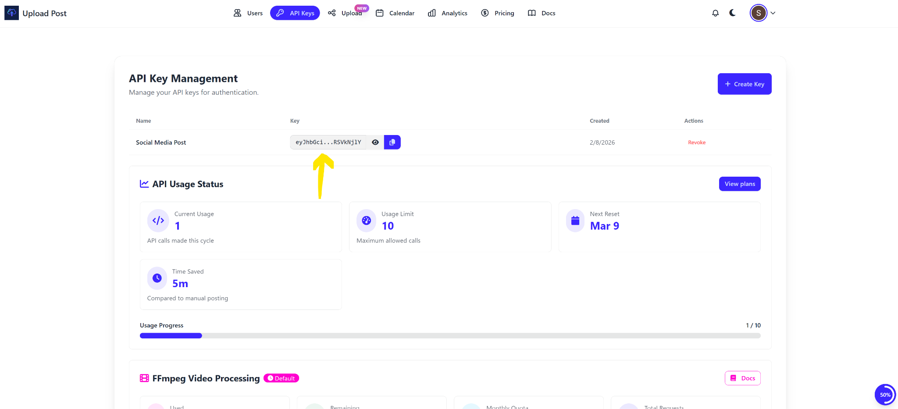

5) Upload the Google sheet “ IDEAS” to the Google Drive (My Drive) (Same account for which the n8n authentication is linked). The Google Sheet titled “IDEAS” has been uploaded to the blackboard.

6) Create two folders as “ Images” and “Videos”, on the Google Drive- My Drive.
Note:
IDEAS Google sheet, and Folders- Images and Videos, should be made public and given edit access.
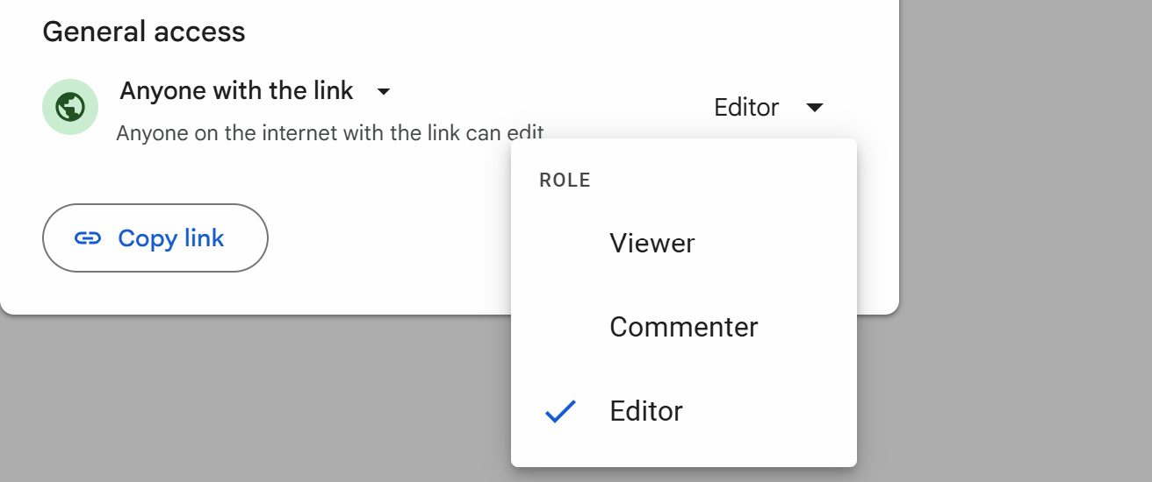

Note: Sometimes the uploaded Excel sheet may be in .xlsx format; make sure to save it as a Google Sheet.

